|  |
| --- |
| ICT 171 |
| Project Proposal |
| ASSIGNMENT 2 |

|  |
| --- |
| Ahaliya Leonard  35468378  GLOBAL IP ADDRESS: 51.21.16.127 DNS: https://unilife.blog/ |

Table of Contents

**SERVER SETUP DOCUMENTATOIN** 2

**SETTING UP DOMAIN NAME WITH HOSTINGER** 4

**SSL certification setup** 7

References 10

# **SERVER SETUP DOCUMENTATOIN**

1. Change the directory to Downloads.



1. Connecting to the EC2 instance vis SSH   
   
2. Update System Packages

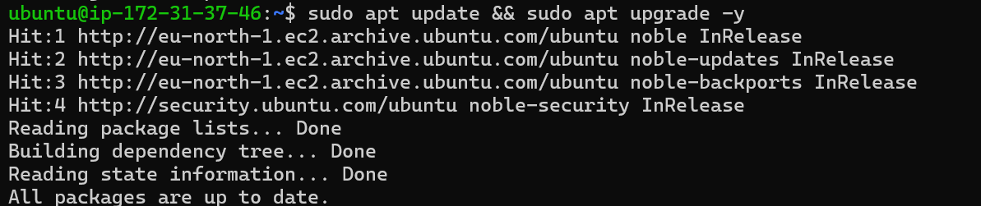

1. Installing Apache2 and git  
   
2. Check UFW status

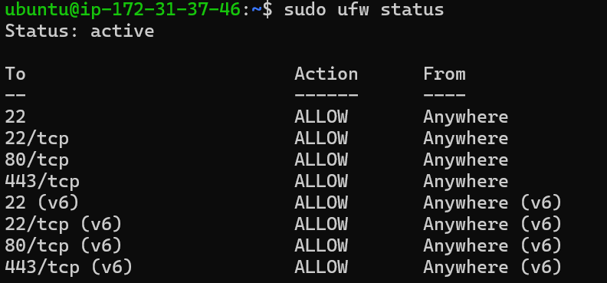

1. Enable UFW firewall



1. Allow necessary ports

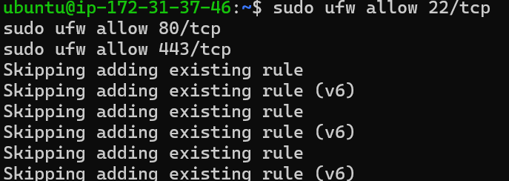

1. Clone GitHub Repository



1. Set the appropriate permissions



1. Copy website files to Apache Directory



1. Change directory



1. Pull latest changes from GitHub



1. Restart Apache Web Server



# **SETTING UP DOMAIN NAME WITH HOSTINGER**

1. Login to your Hostinger account
2. Navigate to the “Domains” section

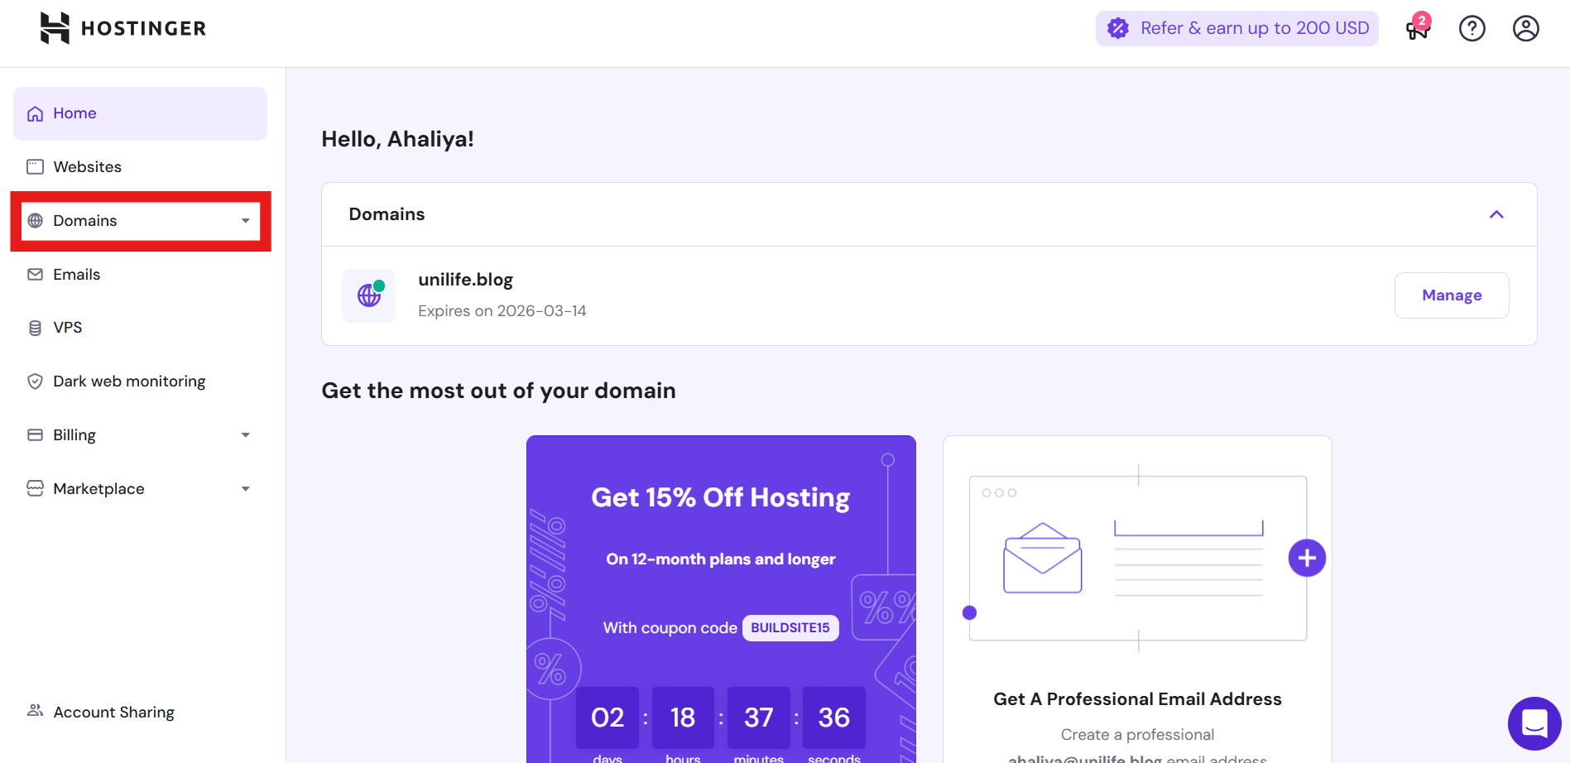

1. Add your domain to Hostinger Account
2. If you don’t already own a domain, you can purchase it directly through Hostinger

1. If you already own a domain, you can skip this step and move on to connecting it to Hostinger.

1. Update DNS setting for your domain

1. Point your domain name to your website and your GitHub repository

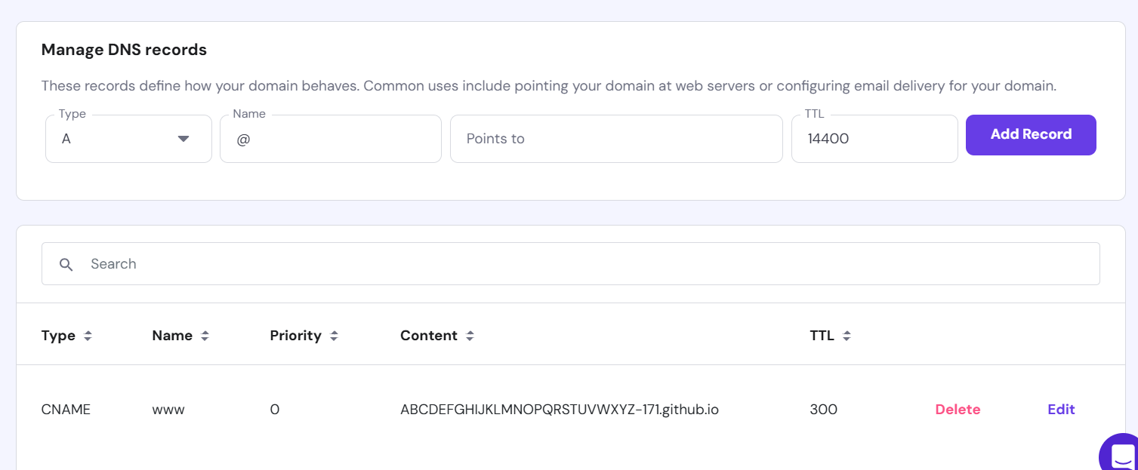

Add records according to the picture below

1. A screenshot of a computer

   Description automatically generatedA white background with black text

   Description automatically generated

# **SSL certification setup**

1. Go to your GitHub repository

1. Click Settings

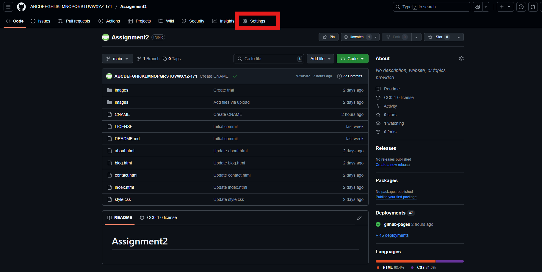

1. Type down your domain name in the custom domain section.

Wait until DNS checking is done and then down below check Enforce HTTPS in which itll produce the SSL certificate

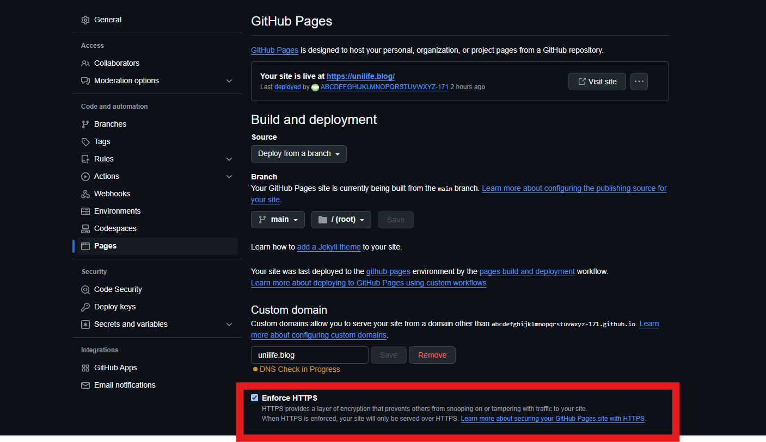

# References

GitHub: https://github.com/

Hostinger : https://www.hostinger.com/